PRACTICAL-2

- Develop a C program that uses the system calls open(), read(), write(), and close() to copy the contents of one file to another. Explain how control transitions between user space and kernel space during execution.
Use the strace utility to trace all system calls generated by the command cat sample.txt. Analyze the sequence of system calls and identify the kernel services involved

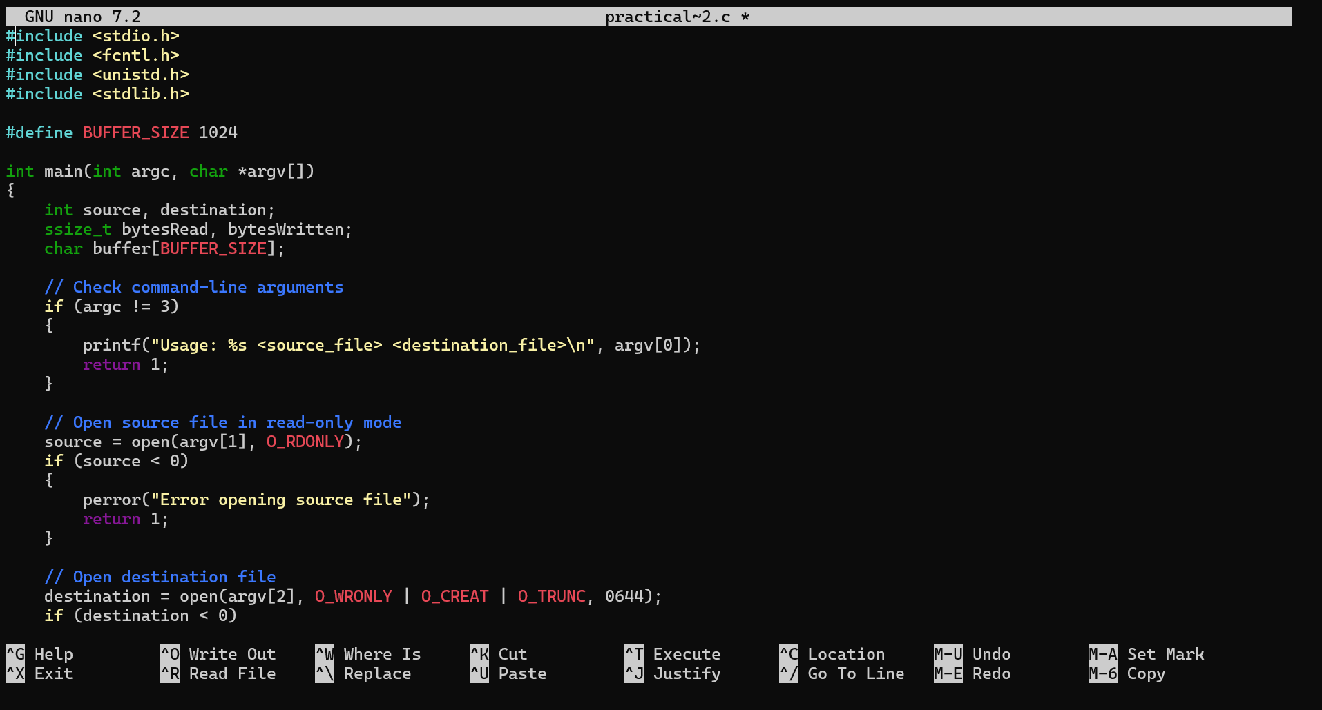
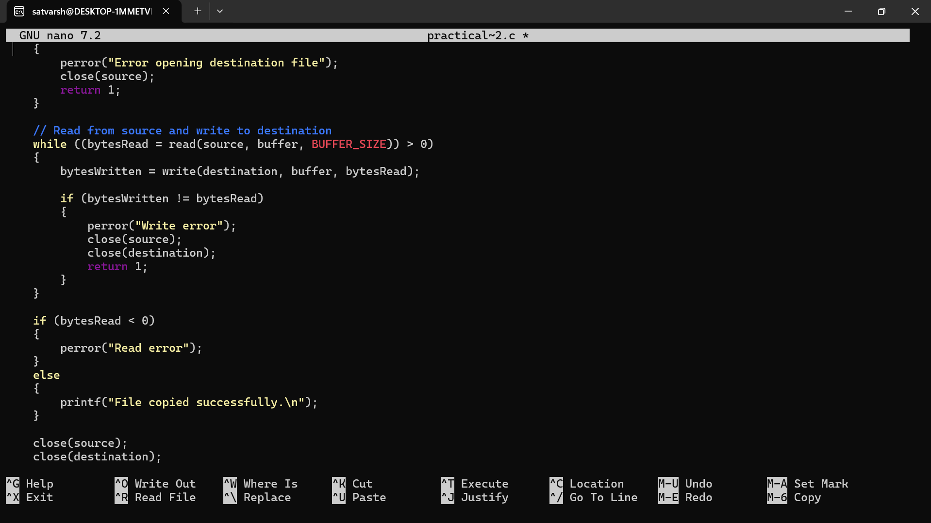
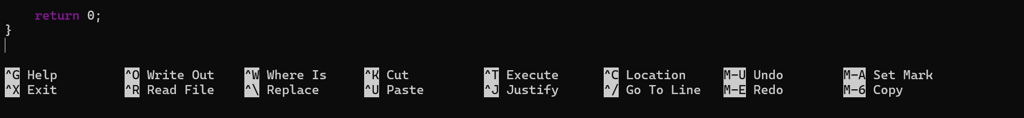
OUTPUT:
